Assignment 1

Secure Programming

B00159127 Lan Ngai, B00159763 Kai Guy

Contents

Authentication Bypass 2

SQL Injection 3

IDOR 4

XSS 4

Credential Leaking 5

Password Visibility 5

Shoulder Surfing 5

Statement of Contribution 6

Exploit Discovery 6

Remediation 6

# Authentication Bypass

‘/admin_panel’ shown in requests when clicking on the sitemap option on the website. That’s how that page was made known to us.

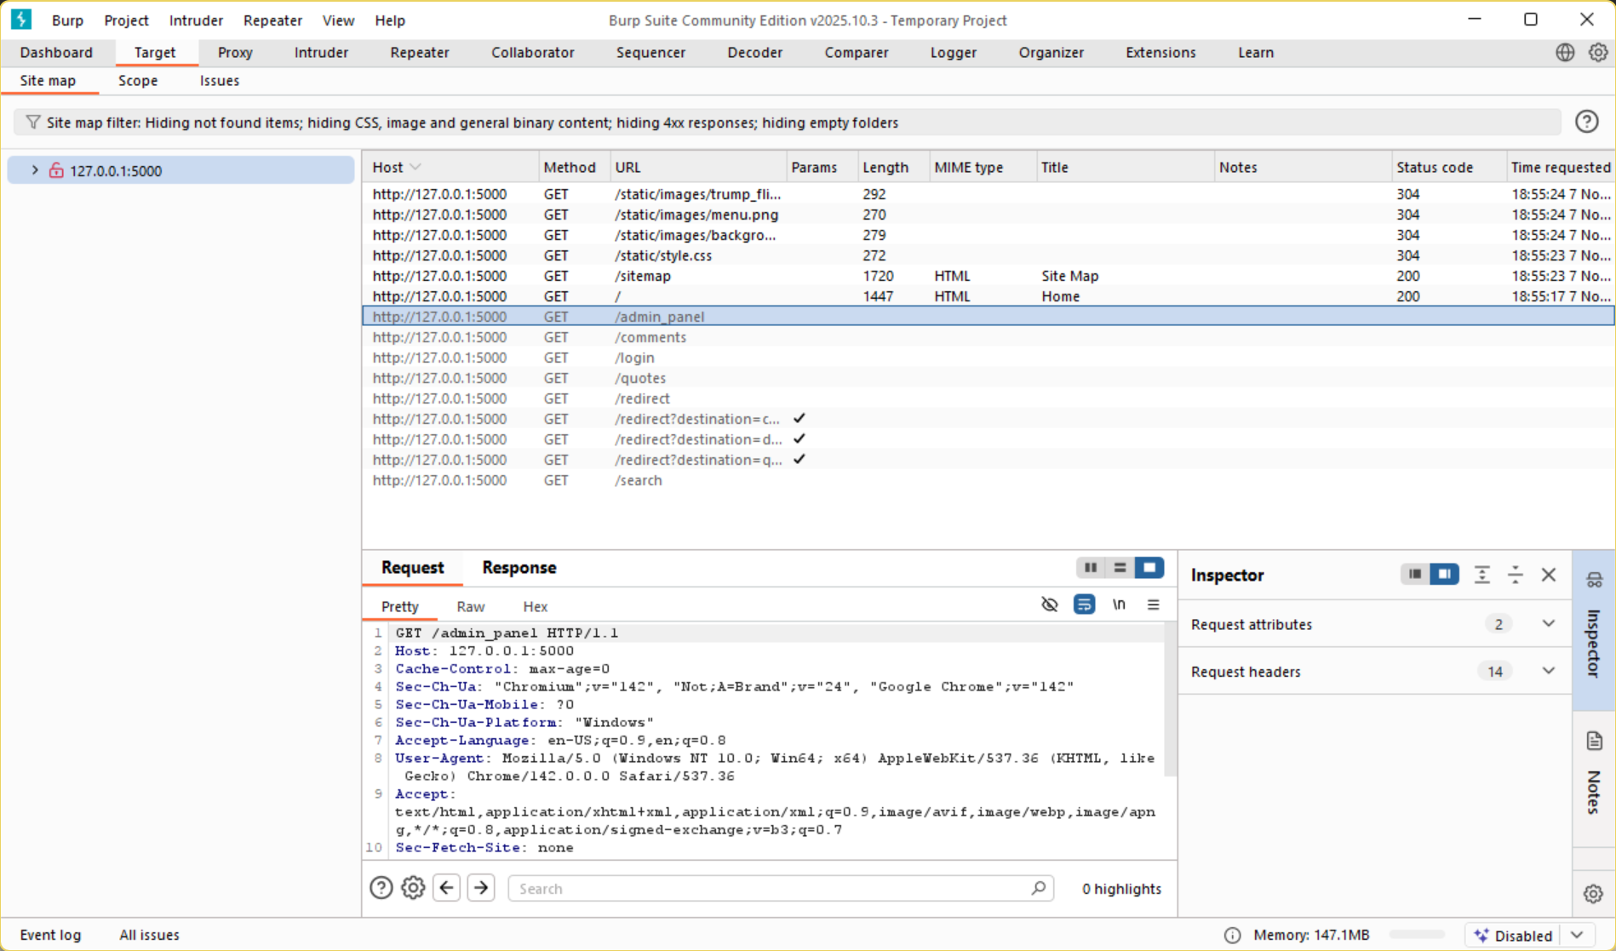

Adding ‘/admin_panel’ we get access to that page which is visible without logging in.

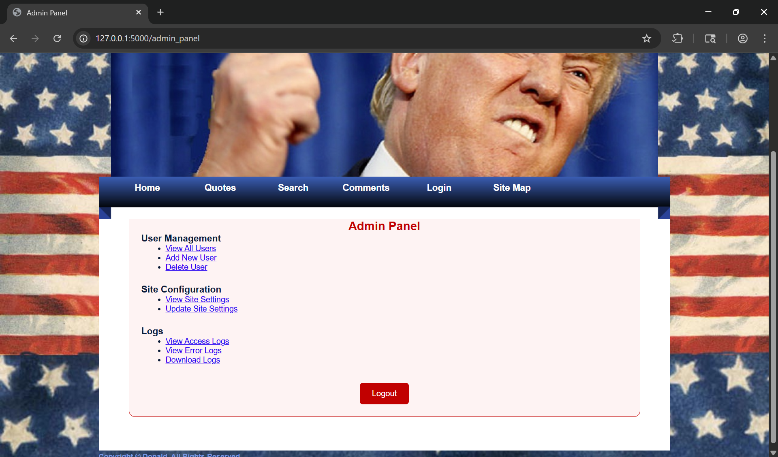

# SQL Injection

In the login page by putting the following (‘OR 1=1 --) in both the username and password fields logs you in due to that being a statement which is always true.

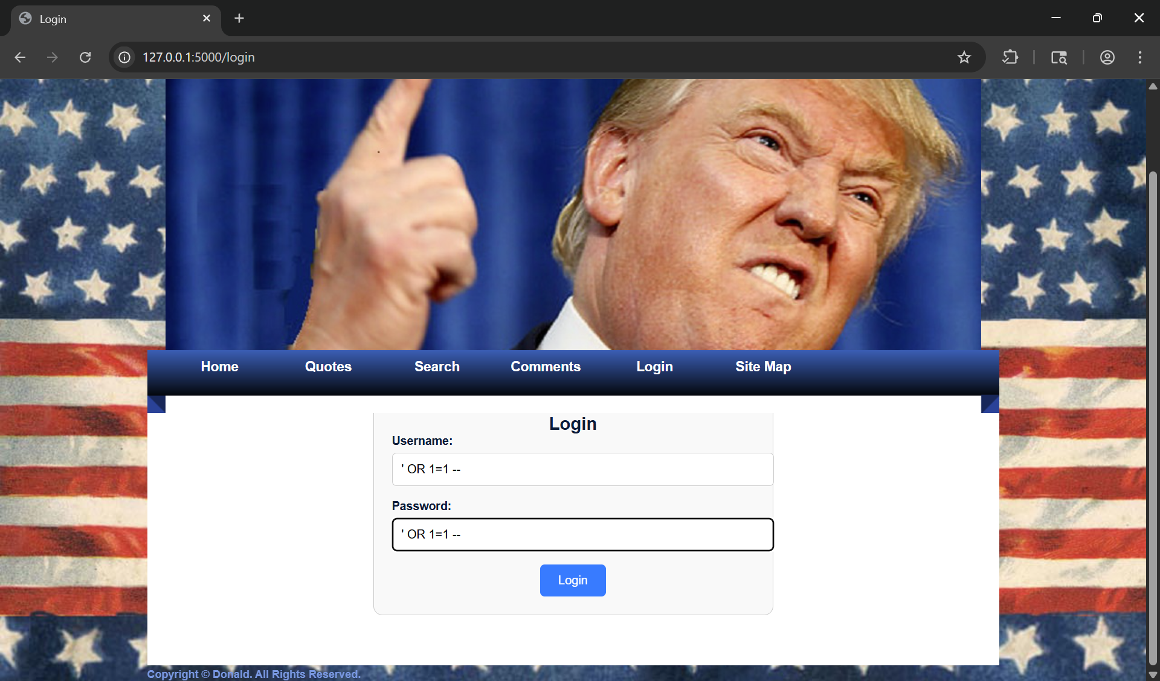

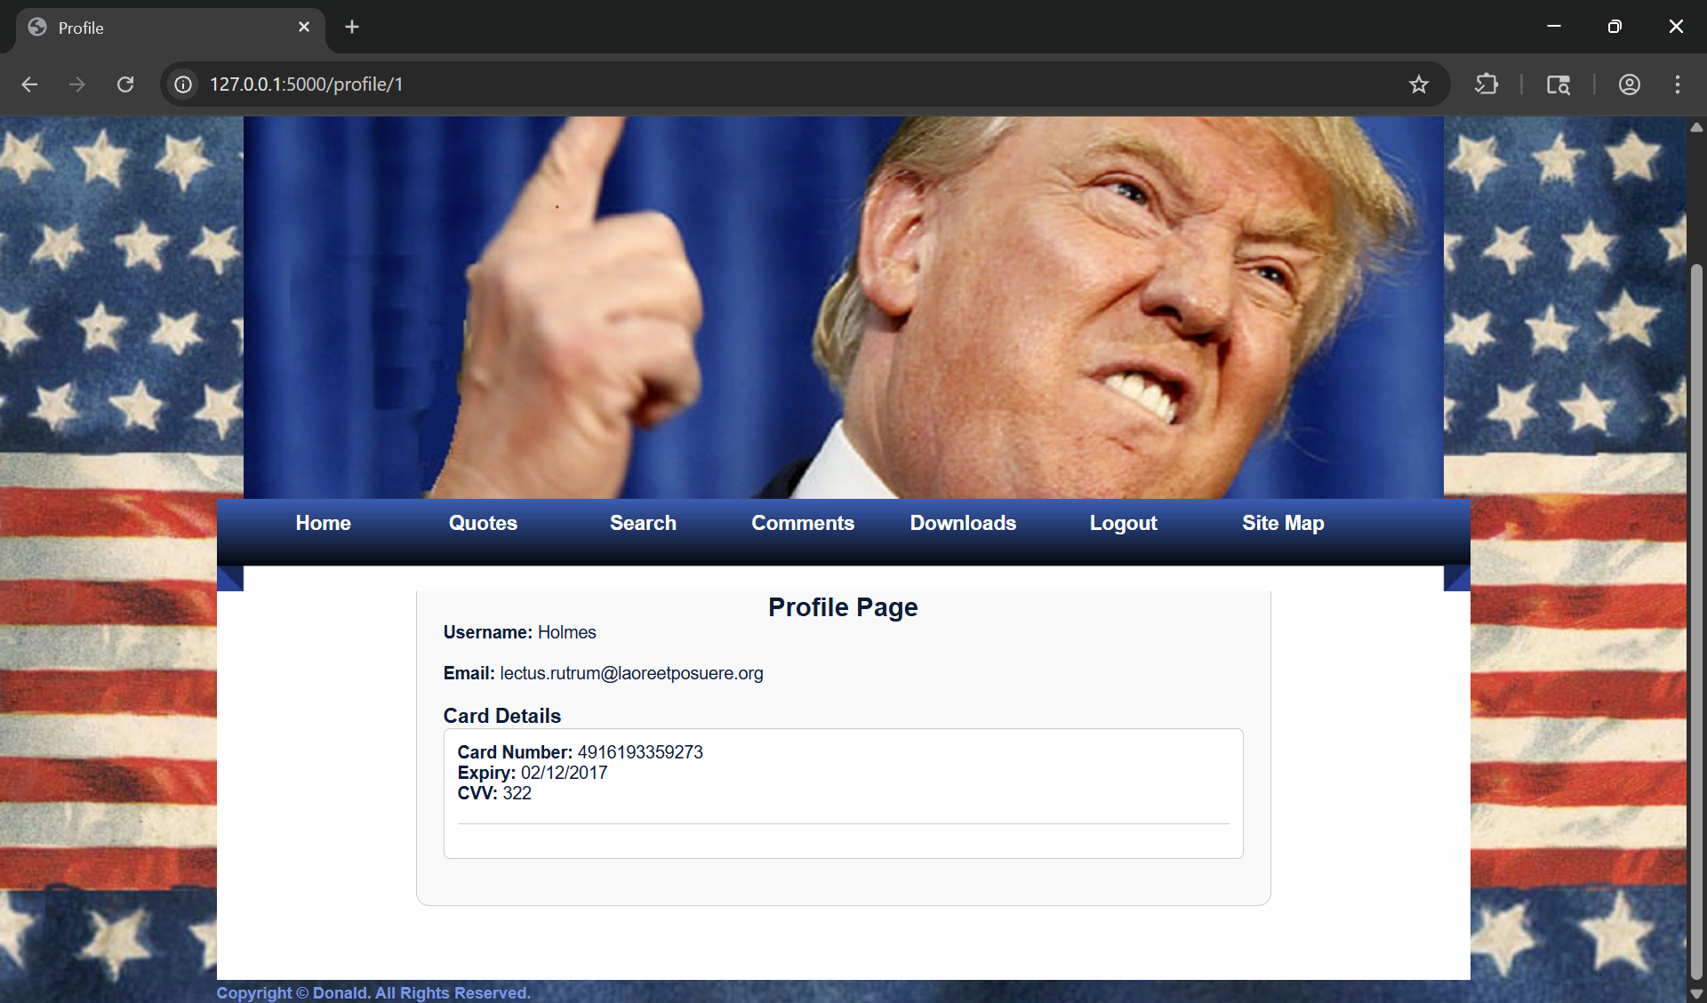

# IDOR

After that I noticed that the Url changed to <http://127.0.0.1:5000/profile/1> so I changed the number and the profile changed to that of another user.

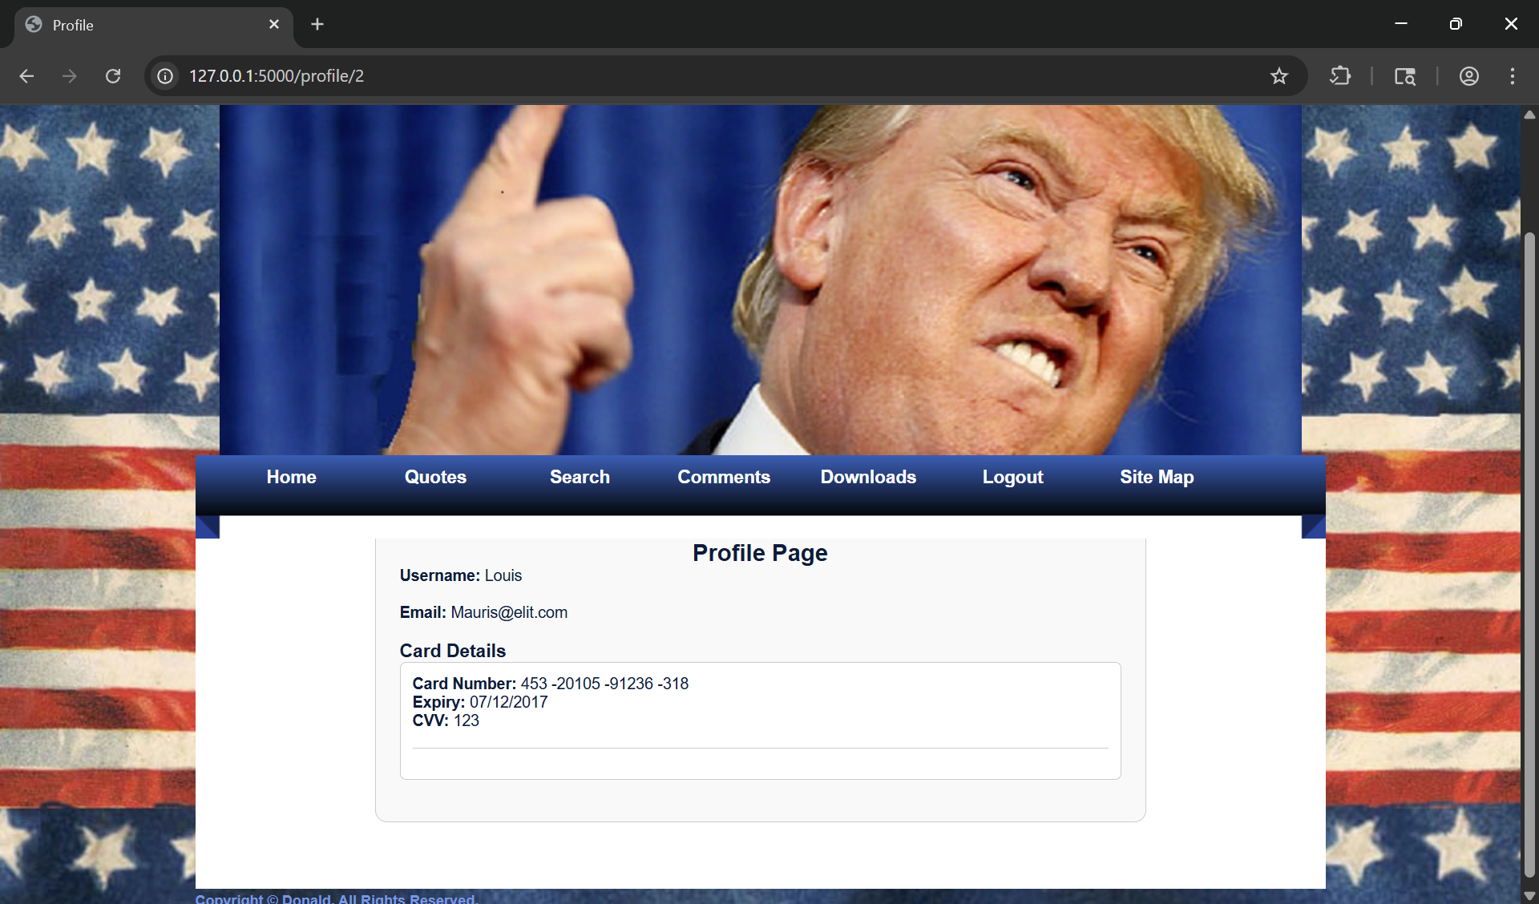

# Reflected XSS

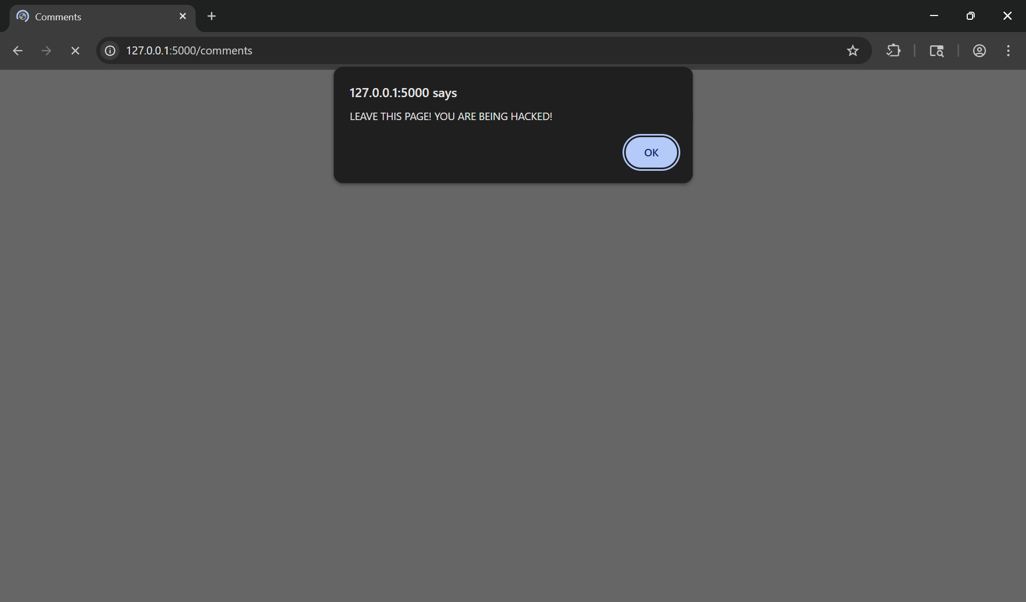

# Credential Leaking

After gaining access to any profile the credit card information of the individual is visible with no hashing or censoring of the sensitive information.



# Shoulder Surfing

The password field in the login page remains so that it’s not hidden. This can allow the user to be prone to shoulder surfing.

# Resource Exhaustion

The comment section of the website does not have a limiter of any sort. This leaves room for malicious individuals to flood the service potentially leading to a denial of service or rapid performance downgrade. This could be taken advantage of through the use of bots or automated tools.

# Statement of Contribution

## Exploit Discovery

## Remediation